Science 9 Final Review

Modified True/False
Indicate whether the statement is true or false. If false, change the identified word or phrase to make the statement true.

1. In a parallel circuit, current goes through all of the devices in the circuit. False – SERIES

2. A voltmeter is used to measure the amount of resistance measured across a resistor. False – OHMMETER

3. The following image is the symbol for a battery. FALSE - RESISTOR
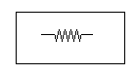

4. The following image is the symbol for a series battery of three cells. TRUE
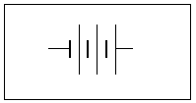

5. The following image is the symbol for a cell. FALSE - OPEN CIRCUIT
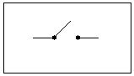

6. The following image is the symbol for a switch. FALSE – LAMP/BULB
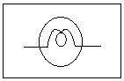

Multiple Choice
Identify the choice that best completes the statement or answers the question.

7. When a charged acetate strip and a positively charged vinyl strip are brought together, they will OMIT
a. | attract one another.
b. | repel one another.
c. | not affect one another.
d. | both become negatively charged.

8. A plastic ball hanging by a string is attracted to a positively charged plastic rod. What can you conclude about the ball?
a. | It could be neutral or positively charged.
b. | It is definitely positively charged.
c. | It is definitely negatively charged.
d. | It could be neutral or negatively charged.

9. When an uncharged object loses electrons, it becomes
a. | fully charged. | c. | neutral.
b. | negatively charged. | d. | positively charged.

10. Which of the following are among the laws of static electricity?

I. | Similar charges attract.
II. | Similar charges repel.
III. | Opposite charges attract.
IV. | Opposite charges repel.
V. | Neutral objects are not attracted to charged objects.
VI. | Neutral objects are attracted to charged objects.

a. | I, IV, and VI | c. | II, III, and V
b. | I, IV, and VI | d. | II, III, and VI

11. Materials that allow charges to flow through them are called
a. | unbalanced. | c. | insulators.
b. | conductors. | d. | balanced.

12. A neutral object has electrons added to it. This object is now
a. | neutral. | c. | uncharged.
b. | positively charged. | d. | negatively charged.

13. Which of the following is an insulator?
a. | aluminum
b. | copper
c. | pure water
d. | salt water

14. Plastic wrap becomes negatively charged when rubbed on fur. Which of the following is true?
a. | the plastic wrap gains electrons; the fur loses electrons
b. | the plastic wrap loses electrons; the fur gains electrons
c. | the plastic wrap gains electrons and the fur gains electrons
d. | the plastic wrap loses electrons; the fur loses electrons

15. A series circuit has three 5 resistors. What is the total resistance of the circuit?
a. | 0.2 | c. | 15
b. | 5 | d. | 45

The following diagram illustrates a circuit consisting of a battery, a switch, and a lamp.
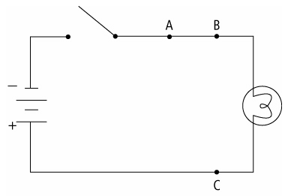

16. In the circuit illustrated above, what will happen to the lamp if a resistor is added to the circuit at point A?
a. | It will get brighter. | c. | It will go out.
b. | It will get dimmer. | d. | It will remain unchanged.

17. You add a second identical lamp to the circuit illustrated above by connecting it from point B to point C. Which of the following is true?
a. | The two lamps are of equal brightness, but they are dimmer than the single lamp was.
b. | The two lamps are of equal brightness, and are as bright as the single lamp was.
c. | The new lamp is brighter than the original lamp.
d. | The original lamp is brighter than the new lamp.

18. The following circuit has three identical lamps connected in parallel.
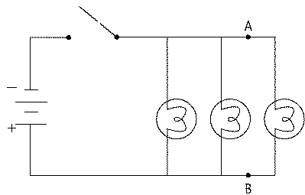
When an electric current is passed through the circuit,
a. | the lamp closest to the energy source will be the brightest.
b. | the lamp farthest from the energy source will be the brightest.
c. | the lamp in the middle will be the brightest.
d. | the lamps will all have the same brightness.

19. If a family receives an electric bill of $122.00 for a month, and the power company charges 10 cents per kW•h, how much energy did the family use?
a. | 122 kW•h | c. | 12 200 kW•h
b. | 1220 kW•h | d. | 122 000 kW•h

20. A home theatre requires 10 A to operate. What is the power of the theatre when it is connected to a 120 V household circuit?
a. | 12 W | c. | 1200 W
b. | 8300 W | d. | 83 W

21. If a dishwasher uses 2 160 000 J of energy in 30 min, what is the power consumption of this appliance?
a. | 1.2 W | c. | 120 W
b. | 12 W | d. | 1200 W

22. If a dishwasher consumes 2400 W of power in 60 min, how much energy has been used by this appliance?
a. | 144 000 J | c. | 1 440 000 J
b. | 864 000 J | d. | 8 640 000 J

23. On a home’s electricity meter, what is measured in kilowatt-hours?
a. | current | c. | resistance
b. | energy | d. | cost

24. Which of the following is used to measure electric potential difference?
a. | Ohmmeter
b. | Ammeter
c. | energy meter
d. | Voltmeter

25. Which of the following is the most common material used in the wires of circuits?
a. | Copper
b. | Aluminum
c. | Silicon
d. | Iron

26. Which of the following is a series battery of two cells? A
a. | 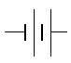
b. | 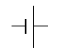
c. | 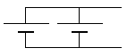
d. | 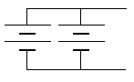

27. What is the purpose of a parallel battery of several cells?
a. | more voltage
b. | more current
c. | less current
d. | less voltage

28. What is current?
a. | total energy contained in the battery
b. | amount of energy flowing in a circuit
c. | total amount of charge
d. | amount of charges flowing past a point per second

29. Which of the following shows resistors in series?A
a. | 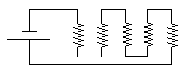
b. | 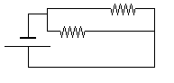
c. | 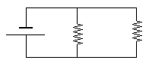
d. | 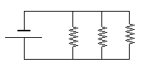

30. Which of the following is the equivalent of three 30  resistors in series?
a. | 90
b. | 10 
c. | 30 
d. | 0.1 

31. Which of the following is the unit for measuring electric current?
a. | ampere
b. | volt
c. | coulomb
d. | ohm

32. Which of the following defines work?
a. | energy
b. | power
c. | effort
d. | change in energy

